NEWS RELEASE Contact info:
September 28, 2016 Dina Gentry
FOR IMMEDIATE RELEASE Communications Director
530-295-2411; dgentry@edcoe.org

EDCOE Preschool Opens at Sutter’s Mill Elementary School
The beginning of this school year brought many new and exciting things to El Dorado County, including a new State Preschool. The preschool program is administered by the Child Development Program at El Dorado County Office of Education (EDCOE) and is located at Sutter’s Mill Elementary School near Lotus. Mary Viegas, Executive of EDCOE Child Development Programs, facilitated the installation and explained, “Increased parent interest prompted EDCOE’s Child Development Programs to establish this flexible and convenient preschool program for families in the area who seek out early childhood education. We are excited about the new State Preschool which is already very successful.”

On the first day of school in August, students eagerly skipped into the classroom ready to learn and make new friends. The transition from preschool to Sutter’s Mill Elementary School becomes much easier as students become familiarized with the campus, educators, and staff before they reach kindergarten. The preschool is one of the 24 preschool programs offered throughout the County from El Dorado Hills to South Lake Tahoe. For more information about preschools or enrolling your child in State Preschool, Head Start or Early Head Start programs, call (530) 295-2270 or visit www.edcoe.org

- ### -

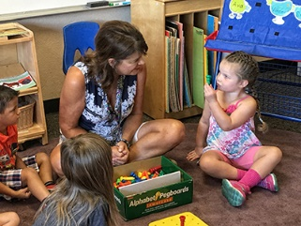
Marianne Kalen teaches students about the letters in the alphabet with puzzles during circle time.

