NEWS RELEASE Contact info:
October 20, 2016 Dina Gentry
FOR IMMEDIATE RELEASE Communications Director
530-295-2411; dgentry@edcoe.org

Placerville Kiwanis Club Installs New Leadership
The Kiwanis Club of Placerville is pleased to announce the installation of new officers for the 2016-17 school year. These community leaders help to mobilize volunteers from the Club’s 70 members to produce a variety of projects and events that benefit the children of El Dorado County. Incoming President Carl Hagen remarked at the installation dinner, “We are appreciative of those who have served during the past year and look forward to what we will accomplish together in the future.”
2016-17 School Year: President – Carl Hagen, Vice President – Jean Meyer, Secretary – Rita Timewell, Treasurer – Jerry Galloway, Advisor to President - Steve Healy, Board Members – Chuck Burns, David Cooke, Stephanie Carlson, Peter Wolfe, Maggie Bush, Gerry Ulm, Steve Healy, Julie Clark, Bob Verzello.
Outgoing Officers: President – Charlie Wiglesworth, Secretary – Rita Timewell, Treasurer – Jerry Galloway, Advisor to President – Bill Snodgrass, Board Members – Taylor Landaker, Debi Harlow, Mike Pettibone.
The Placerville Kiwanis Club was chartered in 1956 and has grown to include many unique individuals, business owners, local agencies, and elected officials. Members collectively volunteer more than 3,000 hours every year in a variety of school and community causes, including Academic Decathlon, Easter Egg Hunt, City of Placerville Fishing Derby, and much more. Money raised through their annual Pasta Feed and Studebaker Wheelbarrow Race help support six high school scholarships and the Central Sierra Regional Occupation Program for Culinary Arts.
Throughout the year, Placerville Kiwanis facilitates three high school Key Clubs (Ponderosa, Union Mine, and El Dorado High Schools), the Markham Middle School Builders Club, and the AKTION Club of El Dorado County. Key Clubs include student members who volunteer for activities like maintaining the Kiwanis Family House which provides lodging for family members whose loved one is being treated at Shriners Hospital for Children or U.C. Davis Medical Center in Sacramento. Community leader and attorney, Paul Zappettini, serves on the Kiwanis Family House board and led a team of Key Club members during a Help Day in September, “Our students work incredibly hard and deserve any help we can provide. They gave up their Saturday for a worthy cause, and it is a privilege to work alongside them. El Dorado County is a special place because of the people who belong to organizations like Placerville Kiwanis.”
Placerville Kiwanis weekly meetings are educational, fun, not mandatory, and provide amazing networking opportunities. Guests are always welcome to attend the first, second, third, and fifth Wednesdays each month at noon and the fifth Wednesday each month at 6 p.m., at the Smith Flat House (2021 Smith Flat Rd. Placerville, CA 95667). For more information about the Club, visit http://www.placervillekiwanis.org/ For questions and information about how to become a member or visit a meeting, contact info@placervillekiwanis.org or call Carl Hagen at (530) 957-0149.
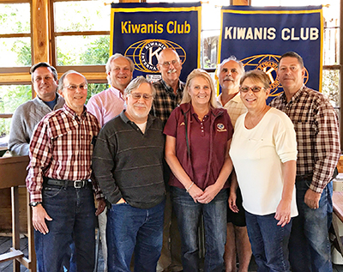
Top row (right to left): Bob Verzello, Chuck Burns, Carl Hagen, Steve Healy, and Charlie Wiglesworth. Bottom row (right to left): Jerry Galloway, Peter Wolfe, Jean Meyer, and Rita Timewell.
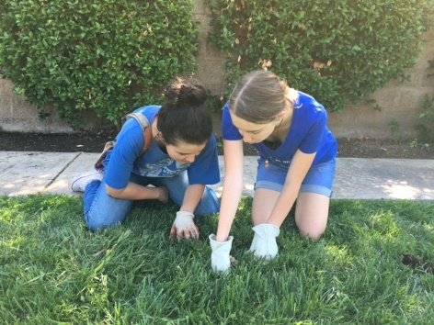
El Dorado and Union Mine High School Kiwanis Key Club members spend a Saturday in September maintaining the Kiwanis Family House in Sacramento by weed pulling, replacing light bulbs, defrosting refrigerators, cleaning kitchens, bathrooms, and much more.

