NEWS RELEASE Contact info:
June 27, 2017 Dina Gentry
FOR IMMEDIATE RELEASE Communications Director
530-295-2411; dgentry@edcoe.org

Montessori Preschool Opens at Valley View Elementary

The Child Development Program at the El Dorado County Office of Education (EDCOE) is pleased to announce that they have moved their Montessori State Preschool program to the Valley View campus in El Dorado Hills for the 2017-2018 school year, and the traditional State Preschool program at Valley View moved to the Blue Oak campus. The Child Development Program currently operates a total of six State Preschools, Head Starts and Inclusion programs on Buckeye District campuses.
“We are fortunate that Buckeye administration values school readiness and that we have a collaborative relationship with Buckeye and their leaders that supports the school readiness of our youngest learners,” Mary Viegas, Executive Director of EDCOE Child Development Programs, explained. While working hand-in-hand with Buckeye Unified School District, the programs have cultivated strong relationships with their students and families.
Mary went on to further describe these offerings that generations of students have experienced throughout the County, “The EDCOE Child Development Programs – like Head Start, Early Head Start, and State Preschool – use researched-based curriculum and assessments that support the best environment and instructional strategies for early learning. Our teachers and instructional staff make the difference! Teachers are highly qualified professionals who ensure children’s experiences in our programs foster school readiness and the social skills needed to succeed.”
Applications are currently being accepted for all Head Start, State Preschool and Home Visiting Programs throughout El Dorado County for the 2017-2018 school year. We are asking families to please call the main Child Development Program phone number at 530-295-2270 or 530-543-8242 for the South Lake Tahoe office. Please call us for more information about our 23 preschool programs or home visiting programs available throughout the county.
For more information about EDCOE and Child Development Programs, visit edcoe.org
###

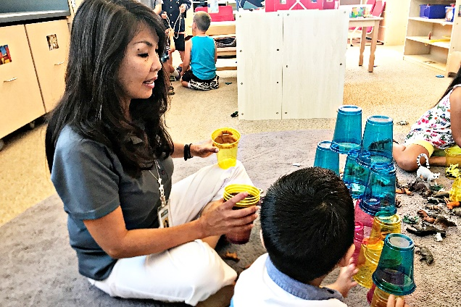
Students participate in engaging activities, like stacking blocks, at the Montessori Preschool at Valley View Elementary in El Dorado Hills.

