NEWS RELEASE Contact info:
January 2, 2018 Dina Gentry
FOR IMMEDIATE RELEASE Communications Director
530-295-2411; dgentry@edcoe.org

Strong Partnerships Feed Families in Need
One of the remarkable things about El Dorado County is our capacity to work together for those in need. Every year, community groups from different sectors take time out of their busy holiday schedules to provide food to families who need it most. This December, 100 families with children in the El Dorado County Office of Education’s (EDCOE’s) Child Development programs, received large boxes filled with enough food for a holiday feast and plenty of leftovers. “Thank you to the county agencies, businesses, volunteers, and EDCOE Child Development team members for making this program possible for our families,” County Superintendent of Schools, Dr. Ed Manansala, expressed.
To raise funds to fill the boxes, the El Dorado County and Shingle Springs-Cameron Park Chambers of Commerce hosted their annual Holiday Luncheon and Gift Basket Auction. Community leaders filled Henry’s Steakhouse at Red Hawk Casino and bid on dozens of donated baskets, elegantly displayed around the room by EDCOE leadership members. Mary Viegas, Executive Director of Child Development Programs, walked baskets around for bidders to see. She added, “It is always amazing to see the generosity of the El Dorado County and Shingle Springs-Cameron Park Chambers of Commerce. This year, they raised $7,650! Thank you to Red Hawk Casino for providing the beautiful lunch, to the Chambers for organizing this event every year, and to those who bid to benefit others! It means a lot to our families and students!”
El Dorado County Chamber of Commerce Chief Executive Officer, Laurel Brent-Bumb, directed the luncheon and noted, “It brings the chamber family such joy to see the generosity of members and friends. It is such a comfort to know that families in need will have a better holiday season.”
Money raised at the auction, along with additional donated funds, was used to purchase pallets of food. Then, the EDCOE Child Development Program team along with the ‘Don Andrews Lunch Bunch’ volunteer group, sorted food into large boxes for the families. This group of friends has donated time and their own funds over the last 30 years because they simply wanted to do something special for the community without expecting any recognition in return.
Brenda Higgins, EDCOE Food Services Supervisor, helped orchestrate the food sorting and box distribution. She acknowledged that “we were able to purchase much more food this year than in years past because of the support we received from Save Mart Grocery – they were amazing to work with. The EDCOE Child Development coordinators make the distribution of all of this food possible including 28 boxes that went to Tahoe. Many of the families come to EDCOE for their boxes, and some walk through that door with nothing at all. However, if they cannot come here for their box, we make sure they receive their food.”
Tanya McBride, who currently has a daughter in an EDCOE preschool program and received a food box last year, addressed the Chamber Holiday Luncheon and emphasized the impact of this collaborative effort, “The box we received last year gave me the ability to purchase other necessities and a few Christmas gifts for my daughter. The box made the holidays a joyous time for our family, and I’m still very grateful to you.”
###
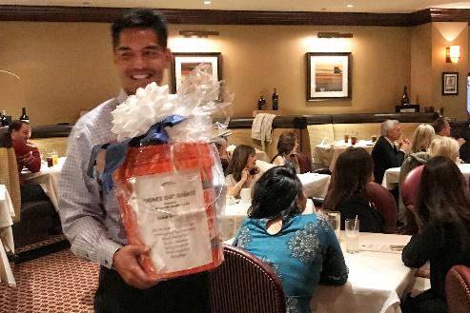
County Superintendent of Schools, Dr. Ed Manansala, helps display baskets to bidders at the El Dorado County and Shingle Springs-Cameron Park Chambers of Commerce annual Holiday Luncheon and Gift Basket Auction.
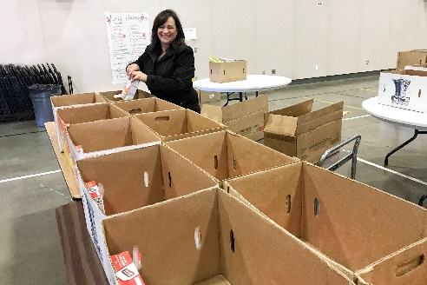
Brenda Higgins, EDCOE Food Service Supervisor, helped to fill 100 boxes full of food for families in need.
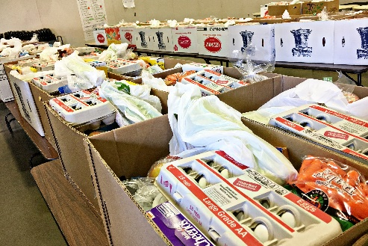
Volunteers filled boxes with food for pick-up and delivery to families across El Dorado County.

