NEWS RELEASE Contact info:
January 11, 2018 Dina Gentry
FOR IMMEDIATE RELEASE Communications Director
530-295-2411; dgentry@edcoe.org

Youth Commissioners Join County Supervisors for Annual Shadow Day
On Monday, January 8, the El Dorado County Youth Commission participated in their annual Shadow Day, in which Youth Commissioners joined the County Board of Supervisors during one of the Board’s regularly scheduled meetings. The students gained valuable insight into how local government operates; how the Board manages issues and policies, such as a public forum; appointments by the board for a variety of commissions and committees; and how to run a formal meeting. Youth Commissioners observed the selection of a new chair and several reports from government agencies.
“We are so impressed with the Youth Commissioners and their interest in local governance,” said Chair Michael Ranalli, District IV Supervisor. “We appreciate them coming out to our meeting and being active participants in the decisions that shape our county.”
Each year the County Board of Supervisors works with the El Dorado County Office of Education (EDCOE) to appoint interested high school students from across the county to the Youth Commission to engage student engagement in local government. Through the program, students gain valuable leadership skills along with the ability to share the perspective of youth regarding local issues. “Our youth hold the keys to a bright future, so the Youth Commission plays a vital role in developing the leaders of tomorrow,” noted Dr. Ed Manansala, County Superintendent of Schools.
“I learned a lot about how local government works and how people enact policy,” said Oak Ridge High School senior Shayan Habibi. “I appreciate even more how our board deals with so many different issues. They have to become experts in a lot of areas.”
The Youth Commission’s mission is to help identify the needs of El Dorado County youth and communicate those needs to their representatives at the local level.
“I hope that students see how local government is one place people can really make a difference,” said Brian Veerkamp, District III Supervisor. “It is one place that being a civil servant can make an impact.”
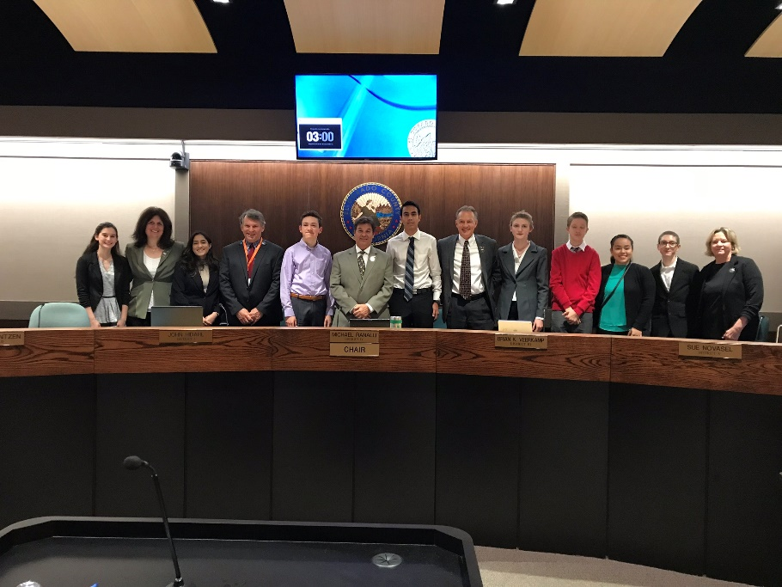
Pictured: (left to right) student Grace Salvestrin, Supervisor Shiva Frentzen, student Misbah Shafi, Supervisor John Hidahl, student Dane Sheridan, Chair Michael Ranalli, student Shayan Habibi, Supervisor Brian K. Veerkamp, student Mackaela Pedersen, student Everet Frame, student Edith Rivera, student Christian Selden, and Supervisor Sue Novasel
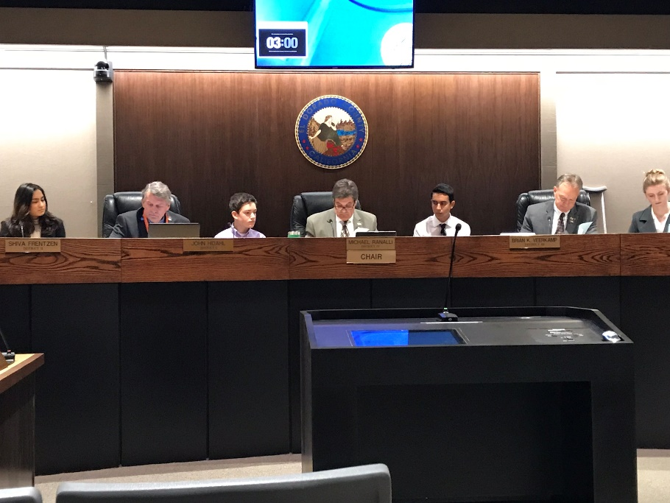
Pictured: The board conducts their meeting with their Youth Commission counterparts observing. (left to right) student Misbah Shafi, Supervisor John Hidahl, student Dane Sheridan, Chair Michael Ranalli, student Shayan Habibi, Supervisor Brian K. Veerkamp, student Mackaela Pedersen
###

