NEWS RELEASE Contact info:
March 12, 2019 Dina Gentry
FOR IMMEDIATE RELEASE Communications Director
530-295-2411; dgentry@edcoe.org

Youth Commissioners Host Board of Supervisors and County Superintendent of Schools
The El Dorado County Youth Commission hosted members of the El Dorado County Board of Supervisors and El Dorado County Office of Education (EDCOE) Leaders on February 13, at the commissioners’ annual Pasta Dinner. The students shared feedback on their focus this year which is the promotion of self-wellness and shifting the way El Dorado County students see and discuss mental health.
“Embracing healthy coping mechanisms to deal with our daily stressors and working toward breaking the stigma surrounding general mental health is important for every student,” explained Youth Commission Vice-Chair Mackaela Pedersen. “We are working toward the promotion of self-wellness in a relatable way – encouraging compassion, empathy, and understanding. Students juggle academic and social pressures 24 hours a day. We function in a world that does not stop, so it is important to make self-wellness a priority, reach out for help if you need it, and connect with other students. As a Commission, we want to help every student feel connected and understand we all deal with similar stresses.”
“It is a delight to see these young people in action, working out their vision and passion for benefiting others,” said County Superintendent of Schools Dr. Manansala. “They are a strong, focused group of leaders who understand first-hand what their peers are going through.”
The Youth Commission helps identify the needs of El Dorado County youth and communicate those needs to our local representatives. The Board of Supervisors and EDCOE co-sponsor the Youth Commission which operates as a youth government. The students learn about local governance while gaining important leadership skills.
“It is truly a unique opportunity for these youth to help shape the future of our county. It is an honor to work collaboratively with EDCOE to support these youth; both agencies are their champions for success,” noted Supervisor Brian Veerkamp, who serves as the Board of Supervisors’ Liaison for the Youth Commission.
Students will take the information and ideas developed at the dinner to improve and advance their passion for a healthier, stronger youth population in the county. “We really appreciate the feedback provided by our county leadership,” said Alexander Hamilton, Youth Commission officer and senior at Ponderosa High School. “The viewpoints and support will help us establish stronger outreach to our peers.”
For more information about the Youth Commission, visit www.edcoe.org
###
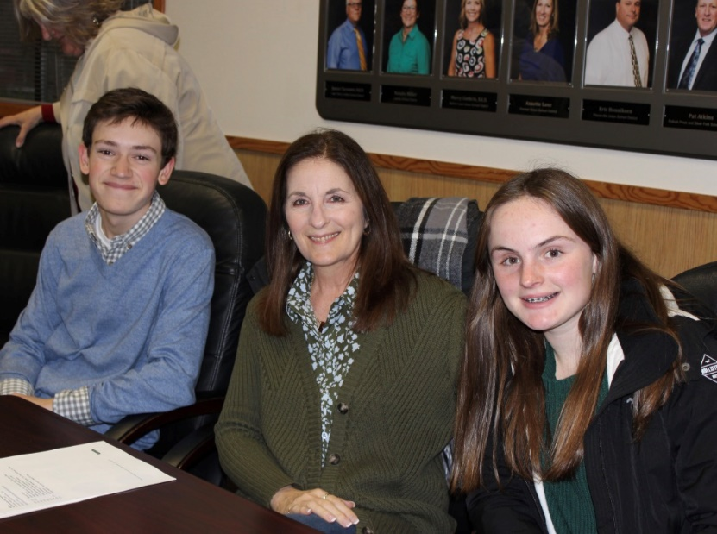
(L to R) Dane Sheridan, Kathy Witherow, Amanda Kendler
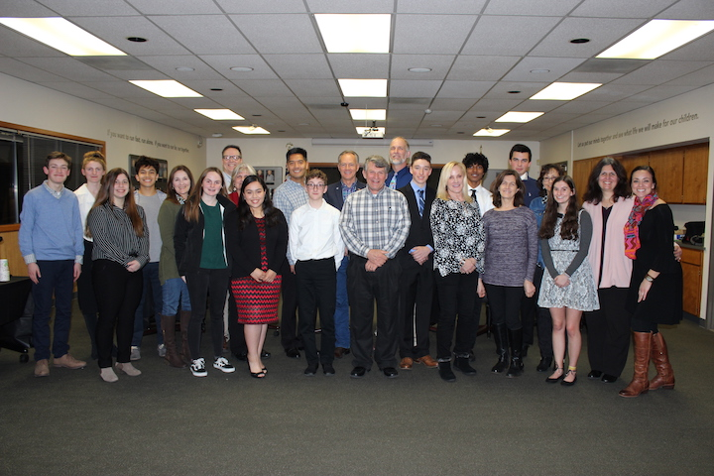
(L to R back row) Dane Sheridan, Mackaela Pedersen, Cassie Giese, Carlos Gonzalez, Kathy Witherow, Jim Mitrisin, Lori Parlin, Dr. Ed Manansala, Supervisor Brian Veerkamp, Kevin Monsma, Travis Oliver, Rithvik Murali, Alexander Hamilton, Elaine Gelber, Supervisor Shiva Frentzen, Amy Pooley (L to R front row) Amanda Kendler, Edith Rivera, Christian Selden, Supervisor John Hidahl, Cindy Munt, Shelley Wiley, Grace Silvestrin
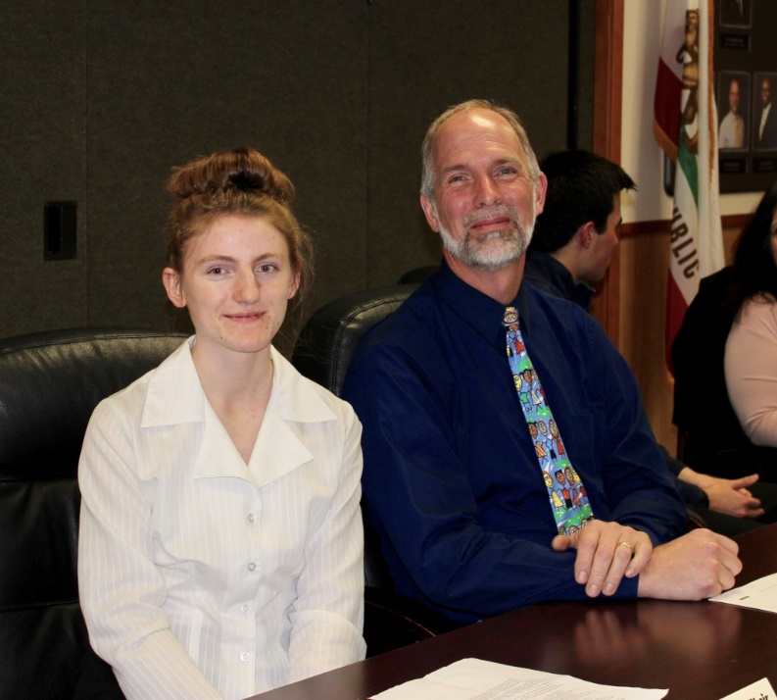
Mackaela Pedersen & Kevin Monsma

