NEWS RELEASE Contact info:
April 3, 2019 Dina Gentry
FOR IMMEDIATE RELEASE Communications Director
530-295-2411; dgentry@edcoe.org

El Dorado County Administrators Honored
On March 15, the Association of California School Administrators (ACSA) hosted a gala at the Catta Verdera Country Club in Lincoln, celebrating Region 2 Administrators of the Year. ACSA Region 2 represents educational leaders from the Northern California counties of Butte, Colusa, El Dorado, Glenn, Nevada, Placer, Plumas, Sierra, Sutter, and Yuba. Several administrators from the local El Dorado Charter were recognized. During the beautiful event, several El Dorado County administrators were recognized. “Congratulations to all of tonight’s awards recipients,” expressed El Dorado County Superintendent Dr. Ed Manansala. “This official recognition by our colleagues is a testament to your work that benefits thousands of El Dorado County students. I’m honored to serve our students with you.”
David Scroggins, Region 2 ACSA President, and Peter Towne, Region 2 ACSA President-elect, presented awards to the following El Dorado County administrators:
Secondary Principal – Lisa Garrett, Ponderosa High School, El Dorado Union High School District (EDUHSD)
Secondary Co-Administrator – Jeremy Hunt, Ponderosa High School, EDUHSD
Elementary Principal – Kim Little, Pinewood Elementary School, Pollock Pines Union Elementary School District
Superintendent/Principal – Grant Coffin, Indian Diggings School District
Confidential Employee – Marti Wallace-Zizek, Director, Fiscal Services, EDUHSD
Continuation/Educational Options Administrator – Chuck Palmer, Director of Education Options and Innovations, Virtual Academy, EDUHSD
Central Office Administrator – Anthony DeVille, Assistance Superintendent Human Resources, EDUHSD
Curriculum & Instruction Administrator – David Scroggins, Assistant Superintendent, Curriculum and Instruction, Rescue Union School District (RUSD)
Business Services Administrator – Lisa Donaldson, Chief Business Official, Mother Lode Union School District
Technology Administrator – Larry Garcia, Information Technology Manager, RUSD
Partners in Educational Excellence – El Dorado Community Health Center (EDCHC), Patrick Klein, Cameron Park, Placerville & Diamond Springs
Marcus Foster Memorial Award for Administrator Excellence – Aaron Palm, Principal, Oak Ridge High School, EDUHSD
Region 2 Sam LaCara Administrator of the Year – Patrick Paturel, Principal, Louisiana Schnell Elementary School, Placerville Union School District
ACSA is the largest umbrella organization for school leaders in the United States, serving more than 17,000 California educators. ACSA’s top priority is advocating for public school students in kindergarten through grade 12, as well as adult learners. Its mission is to be the driving force for an equitable, world-class education system, and the development and support of inspired educational leaders who meet the diverse needs of all California students. For more information about ACSA, Region 2, visit https://regions.acsa.org/2/
###
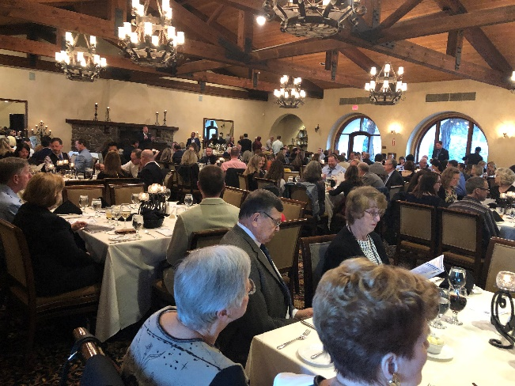
ACSA Gala attendees look on at the Catta Verdera Country Club.
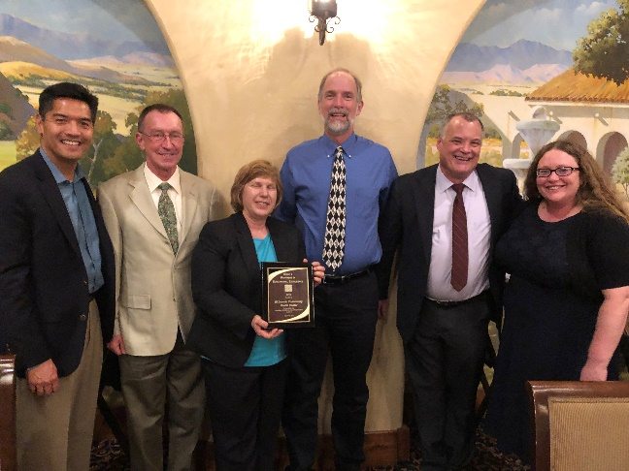
The Partners in Educational Excellence award was given to the EDCHC for their commitment and administration of the El Dorado County Dental Van. From left to right: County Superintendent Dr. Ed Manansala, EDCHC Dental Director Dr. Gene Gowdey, DDS, MA, EdD, EDCHC Dental Supervisor Tina Alhona, EDCOE Deputy Superintendent Kevin Monsma, Patrick Klein, Stefany Gower.
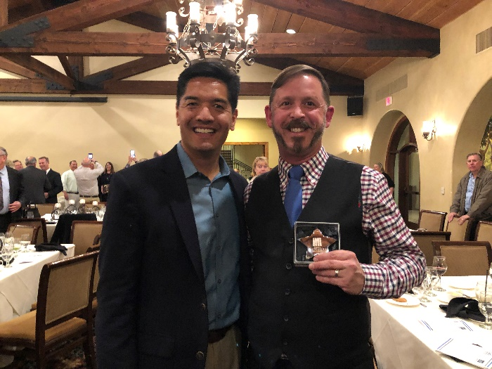
From left to right: County Superintendent Dr. Ed Manansala and Indian Diggings School District Superintendent/Principal Grant Coffin.

