NEWS RELEASE Contact info:
June 6, 2019 Dina Gentry
FOR IMMEDIATE RELEASE Communications Director
530-295-2411; dgentry@edcoe.org

CCA, CUP & CHSA Students embrace Japanese studies
Paper cranes, taiko drums and Shodo calligraphy are commonplace in Japanese high schools 5,000 miles away, and they are a point of pride at the Charles Brown campus in El Dorado. The El Dorado County Office of Education (EDCOE) Charter Alternative Programs of Charter Connections Academy (CCA), Charter University Prep (CUP) and Charter Home Study Academy (CHSA) recently implemented Japanese study programs that allow students to experience a culture far from home.
CCA and CUP have made this cultural exploration a cross-curricular experience by offering Japanese as college-prep courses, teaching phrases in music class, providing hands-on art history instruction and launching El Dorado County’s first Taiko Drumming program – taught by Instructor Sascha Molina, Director of the Sacramento Taiko Dan Youth Ensemble.
“Taiko incorporates movement and is amazing to watch. Students learn teamwork and a bit of the Japanese mindset that working together is powerful and fulfilling,” said Mike Harris, Principal for CUP and CCA.
“By studying Japanese Art History, I hope that the students will understand and appreciate the history, the art, and culture that this island nation embodies,” said Joseph Reichmann, who teaches Japanese, Japanese art and world history. “I hope that the students view Japan as a cultural asset to the world we live in.” Students also learn about preparing a zen garden and participating in a tea ceremony.
Origami cranes are now part of school culture after emerging on campus through a world history lesson on World War II. Students folded 2,000 paper cranes, sent 1,000 to Hiroshima Peace Park in Japan and displayed the remaining 1,000 on campus. Students taught friends and family to fold cranes, and the CHSA art program adopted the practice. “I very rarely go a full day without seeing at least one student folding cranes,” instructor Samantha Parcher said. “It has become a de-stressing technique in study hall. When a student needs a break from work, they’ll fold a crane or two to clear their mind, then get back to academics.”
Over spring break, the CCA and CUP programs culminated in a trip through Japan. Students traveled to Tokyo, Nagano, Kyoto, and Hiroshima. In Nagano, students stayed with host families from CCA and CUP’s sister school, Ueda Nishi High School and attended classes with host students. At Ueda Nishi, the cultural exchange included an assembly, sushi making, flower arrangements, kendo (sword fighting), taiko drumming, a tea ceremony, and free time for students to interact.
“Spending time with the Japanese students was a really great experience. We got to practice some Japanese and see what the culture was like from the perspective of people our own age,” said CCA senior Levi Ainsworth, “Spending time with my host family was one of my favorite parts of Japan.”
At Hiroshima Peace Park - Children's Peace Memorial, the students presented 1,000 paper cranes and visited the Hiroshima Peace Museum.
“This trip was such a learning experience for our students,” said program specialist Steve Bryant, “Learning to navigate the various means of transportation was a very new experience for most of our rural-based students. The trip brought everyday schoolwork to life, as they applied the lessons they have learned throughout the school year.”
Charter Connections Academy and Charter University Prep will organize a trip to Japan available to juniors and seniors every two years. For more information on CCA, CUP or CHSA call (530) 295-2259 or visit charter.edcoe.org
- ### -
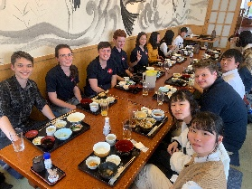
CCA and CUP students dine with Ueda Nishi High School students.
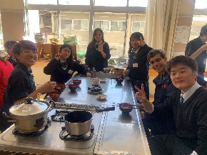
Kendell Eddings and Ian Garmont make miso soup and cucumber sushi.
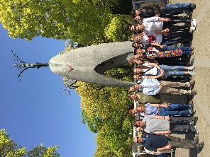
CCA and CUP students deliver 1,000 origami cranes to Hiroshima Peace Park.
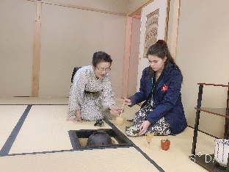
Josefin Green learns the art of the tea ceremony from an Ueda Nishi instructor.
Continued…
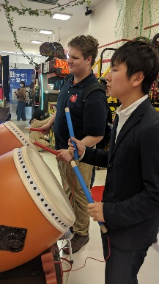
CCA senior Levi Ainsworth plays a Taiko drum video game with an Ueda Nishi student named Taka Ryuichi.

